[Herman J. Russell Westend Academy]
Date: Oct. 4, 2021
Time: 5:30 p.m.
Location: Zoom

- Call to Order 5:33 p.m.
A. Roll Call; Establish Quorum
- Roll Call
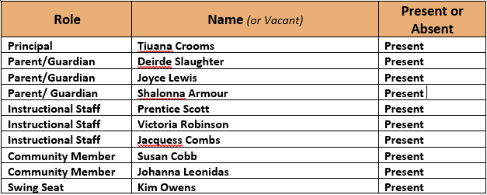

Quorum Established: [Yes]
- Action Items
- HJRWEA Public Comments 2 minutes were given however, there were no comments made.
- Approved Agenda by V. Robinson, then J. Leonidas
- Approved Minutes by j. Leonidas then S. Cobb
- Norms review by P. Scott

- Discussion Items
- Schools needs assessment review by Principal Crooms providing the overview of the schools’ design.
- Principal Crooms provide the teacher to student ratio and the supports students need current due to their results of diagnostic assessments.
- Principal Crooms reviewed the MAP data to demonstrate the students’ academic readiness level.
- Overview was provided on how the CARES Act funding would support the school with increase structures for academic support.
- Information Items
- Principal Crooms reviewed programs and events for HJRWEA VILS and professional staff learning day.
- GO Team Strategic Planning Day Oct. 5th from 7:00 to 9:00 p.m. on zoom with the district.
- Officer Training will be occurring at the latter part of October.
- Meeting adjourned at 6:59 p.m.
-----------------------------------------------------------------------------------------------------------------------------
Minutes Taken By: [Victoria Robinson]
Position: [Secretary]
Date Approved: [Oct. 7, 2021]

